**Aurora Assignment**

**Problem Statement:**

**You work for XYZ Corporation. Their application requires a SQL service that can**

**store data which can be retrieved if required. Implement a suitable RDS engine**

**for the same.**

**While migrating, you are asked to perform the following**

**tasks:**

**1. Create an Aurora DB Engine based RDS Database.**

**2. Create 2 Read Replicas in different availability zones for better**

**infrastructure availability**.

1. Create an Aurora DB Engine based RDS Database.

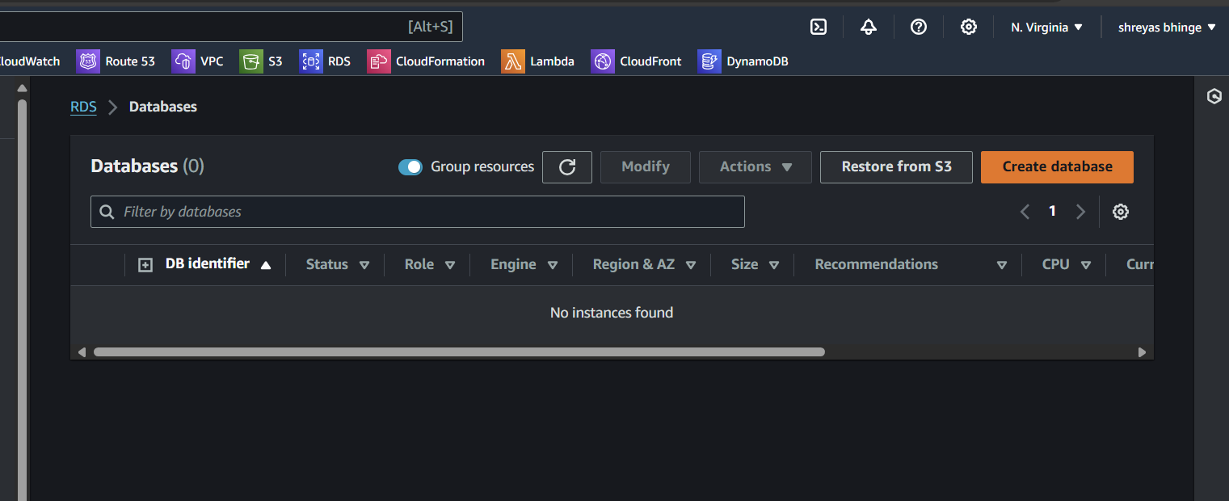

* Create a Standerd Database
* Choose Aurora(MySQl Compatible)

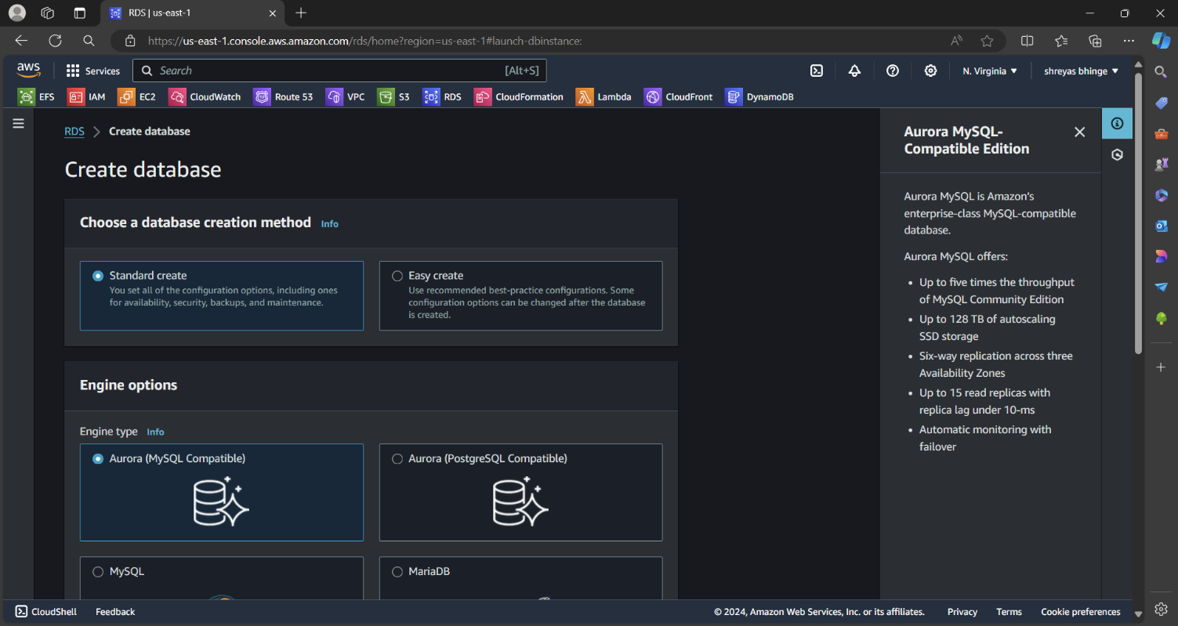

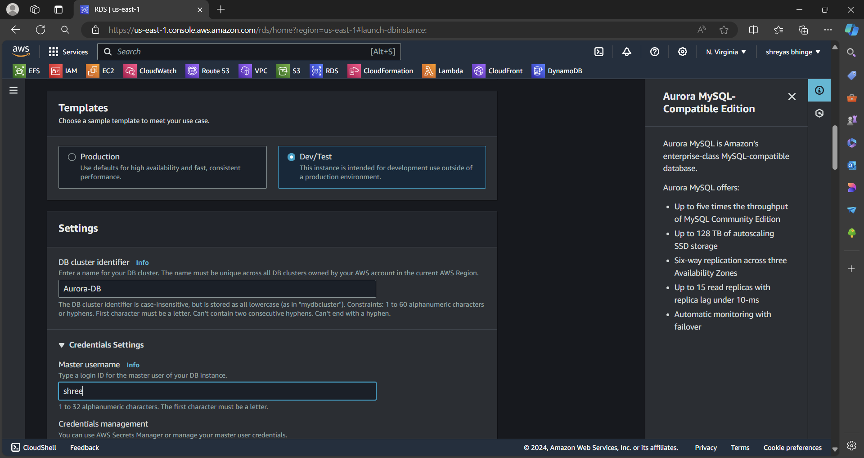

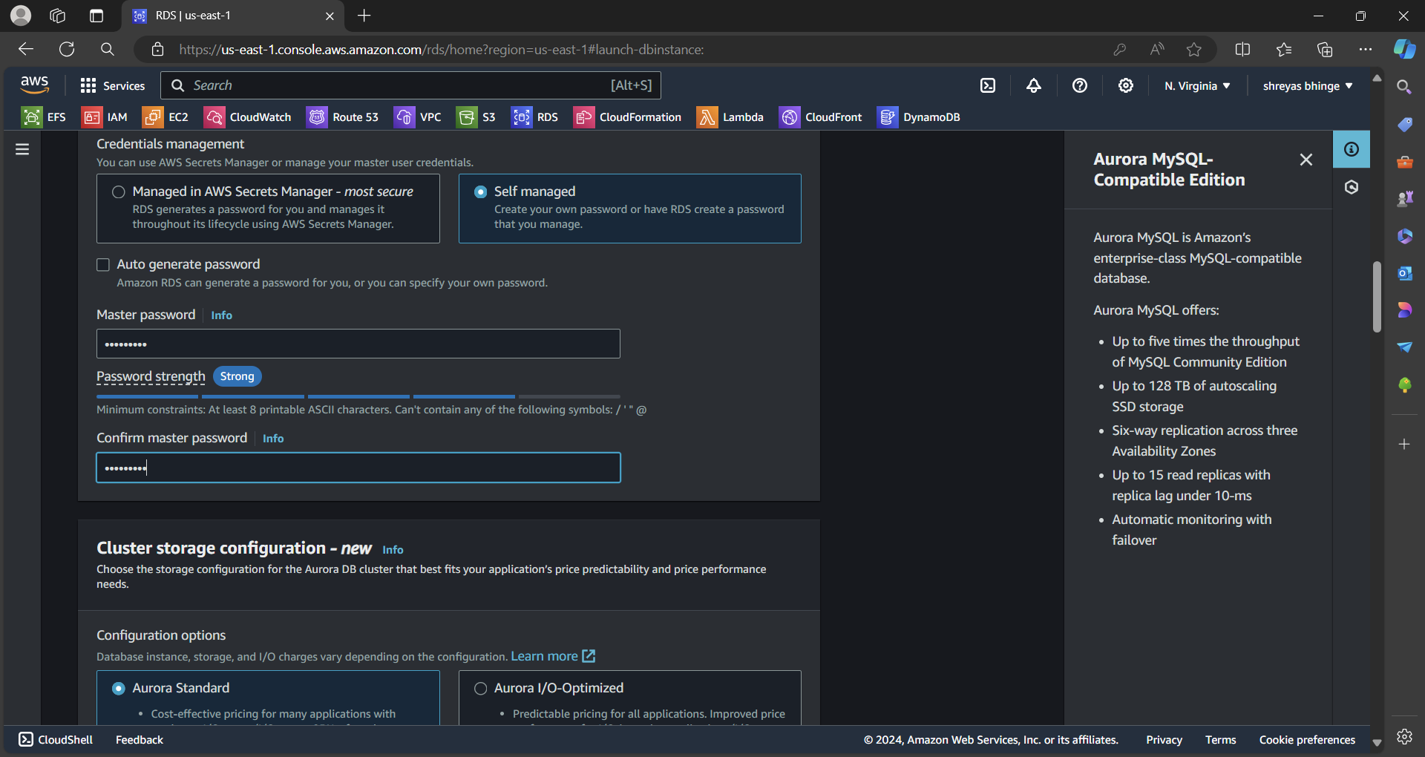

* Configuration Aurora Standard

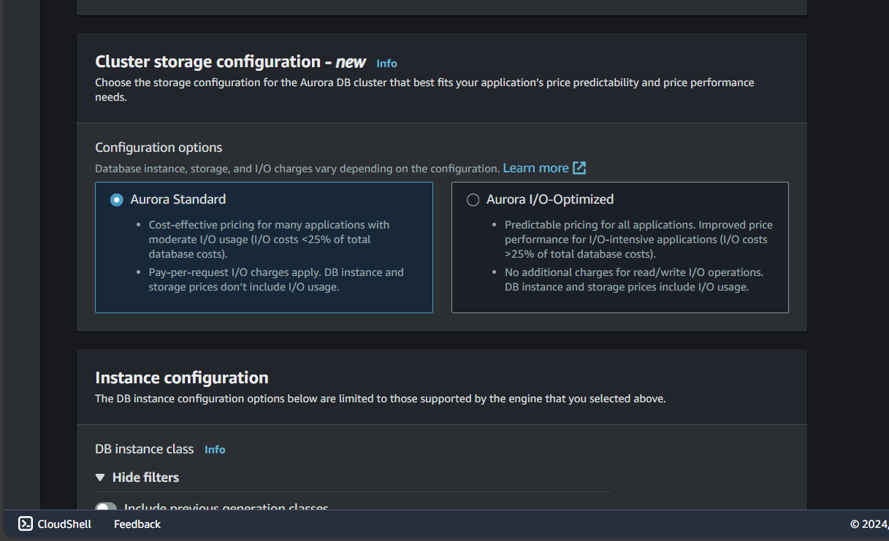

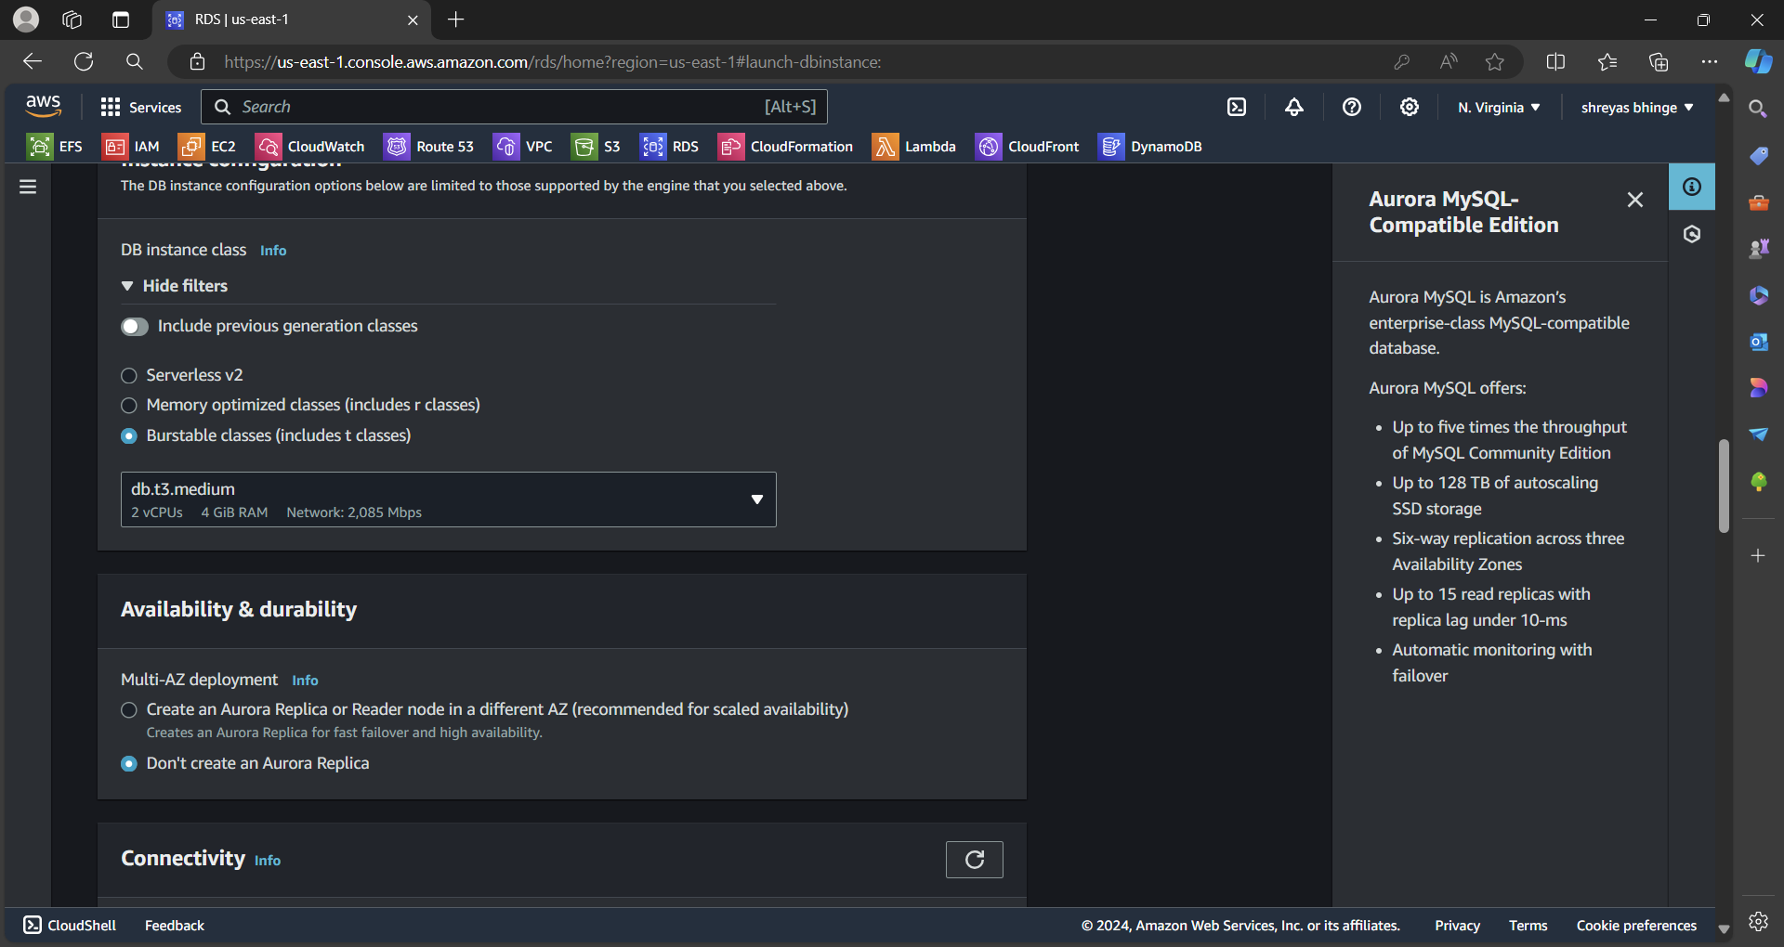

Don’t create a Replica

Don’t connect to EC2 Instance

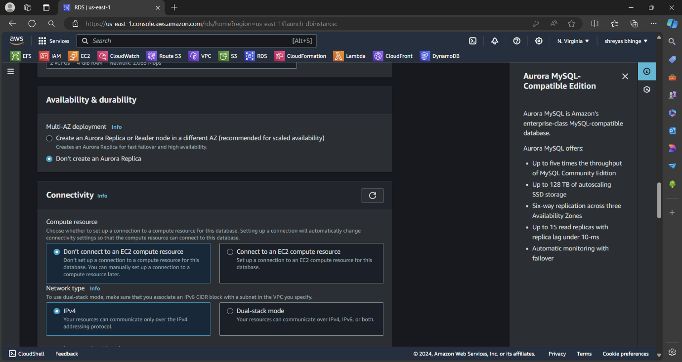

Successfully Create database

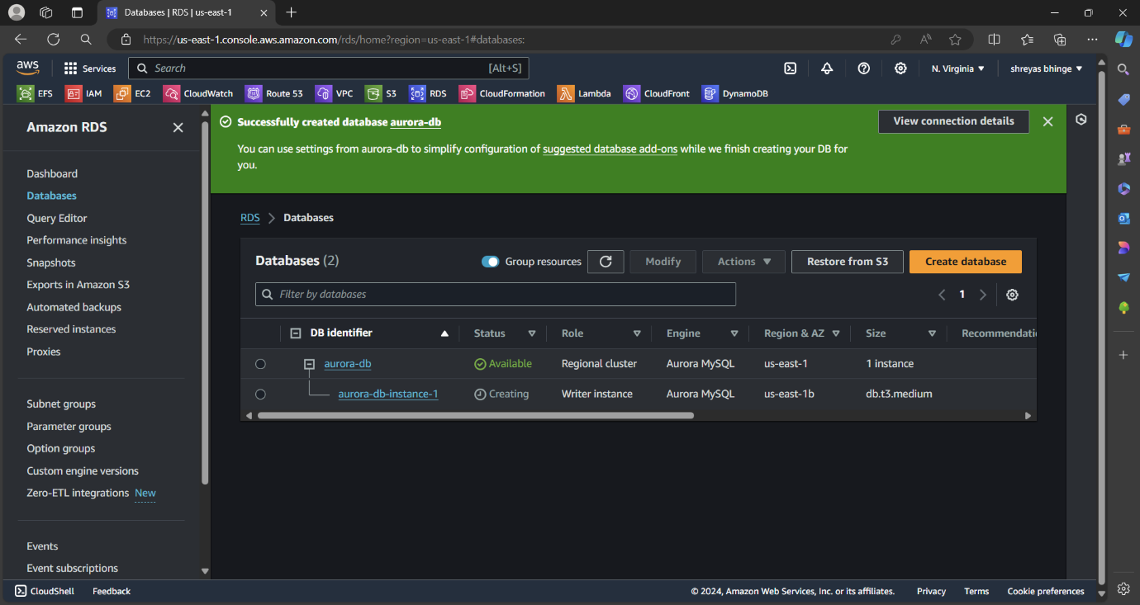

2. Create 2 Read Replicas in different availability zones for better

infrastructure availability.

After Creating go to **Action** and check on **Add Reader**

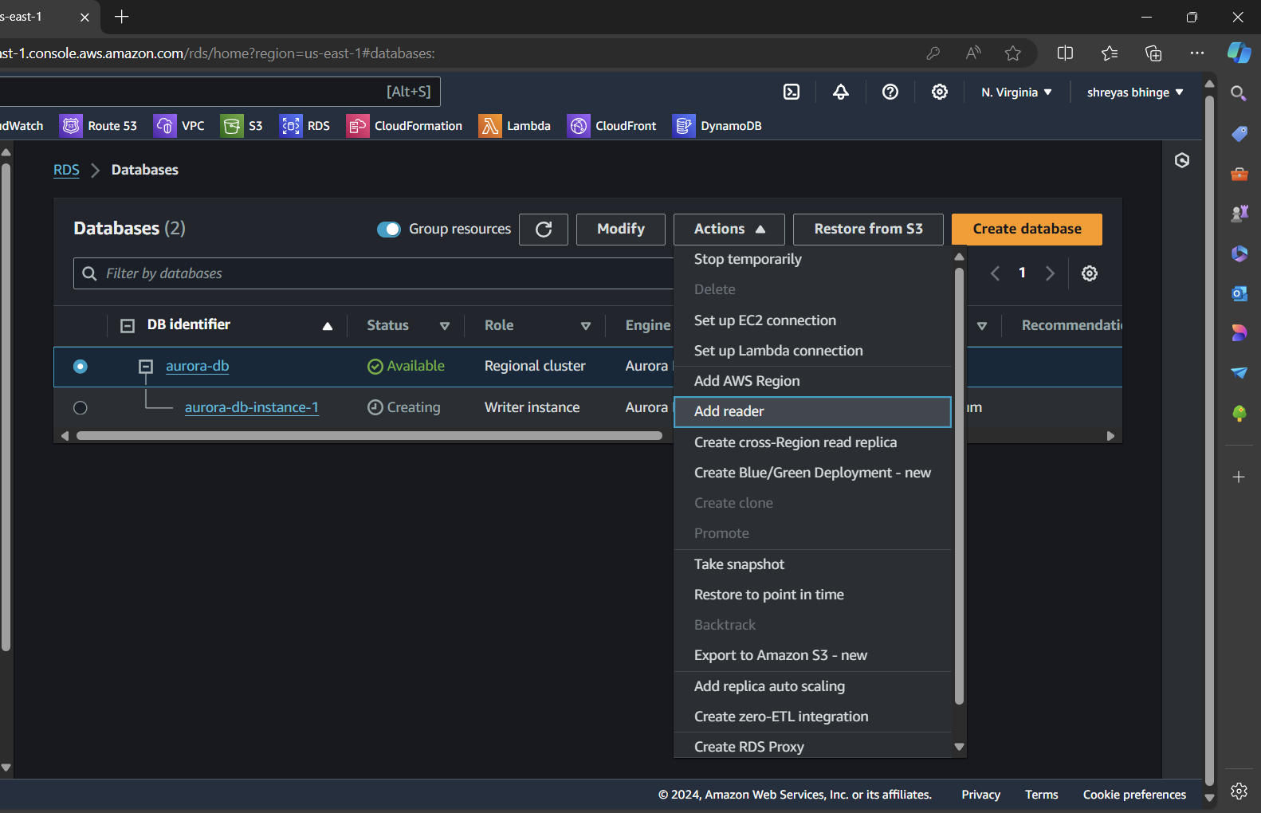

* Db instance identifier as Read Replica-1 and Read replica-2
* Select Different AZ for both the replica

